Sprint Three Report
Portfolio task 7
Unit code: EAT40006
Unit Name: Engineering Technology Project B
Submission date: 12/10/2025

Acknowledgment of Country
Each team member identifies the Traditional Owners of the land they lived on while completing this work.
- Senupama Damdini Deshapriya acknowledges the Wurundjeri Woi Wurrung people as the Traditional Owners of the land they lived on while completing this work in Melbourne, Victoria.
- Chrishelle Anthoneyz acknowledges the Wurundjeri Woi Wurrung people as the Traditional Owners of the land they lived on while completing this work in Melbourne, Victoria.
- Haritha Manuja Perera acknowledges the Wurundjeri Woi Wurrung people as the Traditional Owners of the land they lived on while completing this work in Melbourne, Victoria.
- Thenura Dulnath Kuruppuarachchi acknowledges the Wurundjeri Woi Wurrung people as the Traditional Owners of the land they lived on while completing this work in Melbourne, Victoria.

Contribution summary (This Sprint)

 | Contribution | Initiatives | Communication |  |  |  |  |  | Respect
Team Member | Finished tasks in time or on time with an acceptable quality | Self-assigned tasks and proactively found solutions to problems | Attended all team meetings | Attended all supervisor meetings |  | Attended all client meetings | Replied every time within an acceptable timeframe | Kept the team updated about the status | The student respected others and listened to different opinions
Thenura Kuruppuarachchi | Yes – led integration of the final GLB model and ran sensor tests with the hardware team to ensure full app connectivity. | Yes – troubleshot data flow between app and sensors and coordinated team debugging efforts before final testing. | Yes |  | Yes | Yes | Yes | Yes | Yes
Haritha Perera | Yes – completed the full integration of the 3D model into the app and fixed animation-related bugs for final validation. | Yes – took initiative to optimise model features and tested responsiveness during hardware integration. | Yes |  | Yes | Yes | Yes | Yes | Yes
Senupama Deshapriya | Yes – finalised the compact model for mobile performance and resolved export and rendering bugs. | Yes – co-authored the Testing Manual and contributed to test documentation and model validation steps. | Yes |  | Yes | Yes | Yes | Yes | Yes
Chrishelle Anthoneyz | Yes – completed the User Manual, contributed to the Testing Manual, and managed final documentation for handover. | Yes – created UI background and oversaw documentation structure and final report submission. | Yes |  | Yes | Yes | Yes | Yes | Yes

Contribution Details (This Sprint)

Thenura Kuruppuarachchi
Thenura resumed his responsibilities as Scrum Master. He was instrumental in converting the last of the SolidWorks model into a GLB format and preparing it for complete app integration. He organised the testing of the SolidWorks model with the hardware group, in terms of connections with sensors and ensuring live data responses in the app itself. He also undertook testing of the sensor units to validate whether the correct data was being transmitted to the app, and helped troubleshoot bugs related to model exporting. Thenura validated that the model rendering was correct at all times, fixed minor visual issues, and confirmed that everything was ready for the final showcase presentation. Thenura coordinated meetings, updated Jira tasks, and created a number of Git commits related to 3D rendering and connectivity within the app.
Haritha Perera
Haritha completed the integration of the 3D model into the mobile app environment, and tested how app-side components interacted with the GLB model. He was attentive to refining features and functionality within the model itself, making sure that sensor mapping and animations functioned accordingly in the app environment. He worked closely with the hardware team during end-to-end testing, validating real-time data visualization during tests. While working on individual assignments, he fixed minor bugs from earlier integration notes, and contributed to the preparation of the final testing report. Haritha produced a number of Git commits and closed out numerous Jira stories related to animating refinements and system validation.
Chrishelle Anthoneyz
Chrishelle's focus in Sprint 4 was documentation, outputs and interface design. She worked on the User Manual and also contributed to the Testing Manual to make sure that users could follow the steps appropriately in navigating the app, processes for testing outcomes, and how to handle data output. Chrishelle worked on the background of the app interface, and confirmed that the design and visual was coherent with the client feedback. maintaining simplicity and accessibility. She contributed to the final documentation prep for the model, assisted in validating app testing results, and supported in preparing the team's final documentation for handover. Chrishelle made sure that she was consistent with any updates in Jira and with Git commits, collaborated on laying out the Sprint report, and reported on meeting notes for each client and supervisory meeting.
Senupama Deshapriya
Senupama produced a compact version of the composting model, which was refined for working seamlessly in both mobile app and web-based environments. She worked on the occasions of bug fixing that was recommended from tests previously and ensured the model rendered with no visual lags, as well as corrected responses in the mobile app. Senupama contributed to the Testing Manual and documentation, which included documenting the test instalments of model functionality, app feedback/responsiveness, and system validation. She coordinated with Chrishelle to confirm the formatting and content in the documentation. Senupama attended both the client and supervisor meetings, and contributed to the discussions that were happening through testing phases. She posted updates in Jira throughout development and documentation connected to model performance and debugging issues.
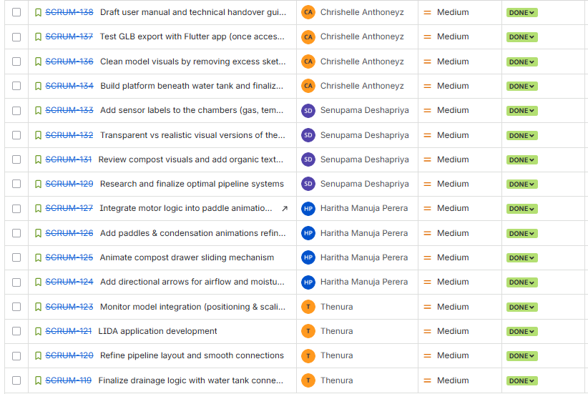
Figure workload equally distributed among the team members

sprint plan
Sprint 3 focused on system integration, testing preparation, and documentation finalisation.
Building on Sprint 2, the team aimed to complete the LIDA Composting System as a fully connected hardware software prototype. The main goals were to integrate the final SolidWorks model into the mobile app using the GLB format, validate sensor data mapping, and produce the required user, testing, and deployment manuals for client submission.
Scrum Master: Thenura Kuruppuarachchi
Sprint Goal:
To verify the complete linkage between the 3D model and the Flutter-based mobile app, ensure that live sensor data is displayed accurately, and finalise all documentation required for testing and handover.
Sprint Backlog Highlights (Week 7 – 9):
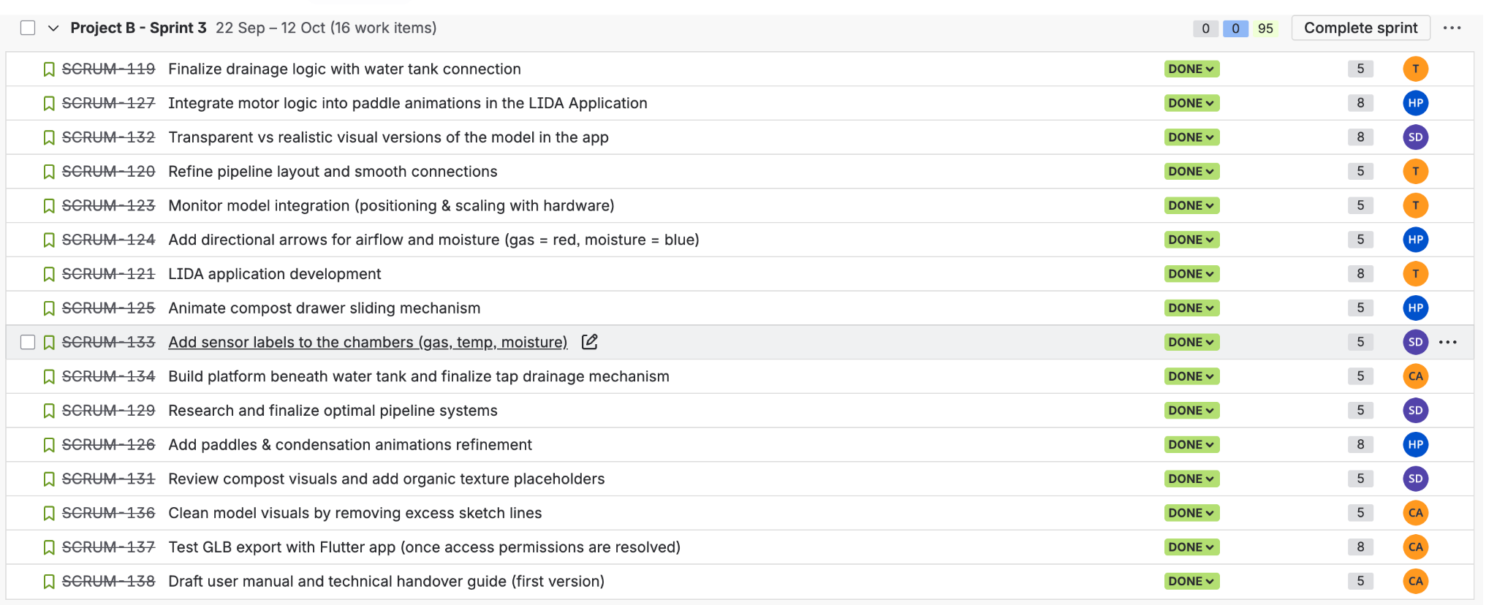
Artifacts Produced:
- Integrated 3D GLB model in mobile app.
- Functional sensor panel showing real-time gas, temperature and moisture data.
- Updated animations and UI optimisation.
- User Manual, System Installation Manual, and Software Testing Document (drafts completed this sprint).
- Usability testing survey templates for Sprint 4.
Planning Summary:
Sprint 3 was planned for Weeks 7 to 9 (16 September – 5 October 2025). All technical tasks were completed within schedule; documentation activities continued through Week 10 to prepare for final review and submission. Jira evidence shows steady progress with parallel task completion across integration and documentation streams.

final documentation deliverables
The following documents were produced and attached as part of Sprint 3’s outputs:
1. System Installation (Deployment) Manual – LIDA Composting System
This manual provides detailed setup and deployment procedures for both the 3D model and the mobile app. It outlines system components, hardware/software requirements, installation steps, sensor simulation setup, and troubleshooting guidelines. It serves as the reference for technicians or administrators installing and testing the LIDA system.
2. User Manual – LIDA Composting System
Designed for end users, this manual guides the user through launching the 3D model and mobile app, viewing live sensor data, and operating animations that simulate composting stages. It includes maintenance tips, troubleshooting steps, and ethical guidelines to ensure safe and responsible usage.
3. Software Testing Document – LIDA Composting System
This document defines the testing framework used during Sprint 3, covering unit, integration, and system testing phases. It specifies test environments, roles, test cases, and expected outcomes based on IEEE 829 standards. Evidence from Jira and internal screenshots is included to validate functionality and performance of the 3D model and mobile app integration.
Together, these three documents form the core of the project’s technical handover package, ensuring that the system can be easily installed, used, and tested by future developers and stakeholders.

sprint progress
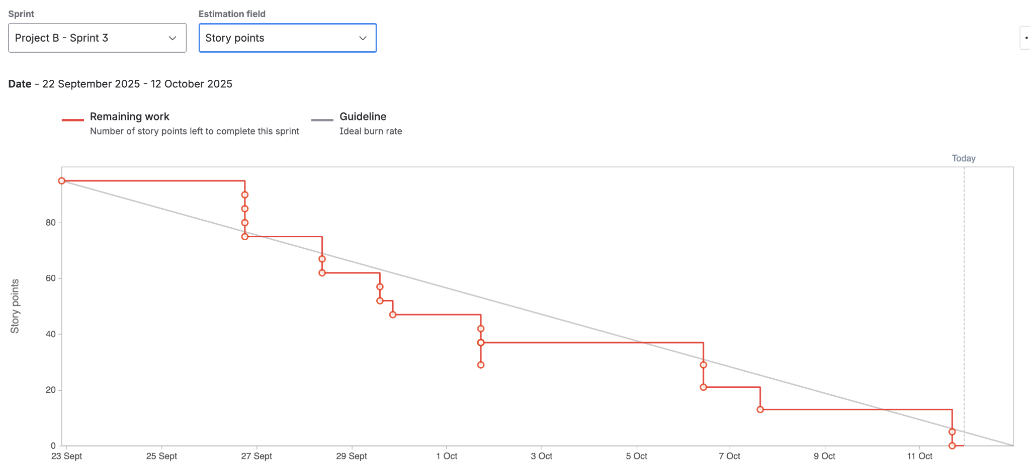
Sprint 3 was the culmination of the team’s technical and documentation efforts, focusing on integration, testing readiness, and deliverable completion. All team members worked concurrently on their assigned areas, as shown in the Jira updates. The non-linear burndown reflected the parallel nature of integration and documentation work, with multiple tasks completed simultaneously.
Integration and Testing (Thenura Kuruppuarachchi):
Thenura continued as Scrum Master and oversaw the conversion of the SolidWorks model to the GLB format for app integration. He tested sensor responses with the hardware team to ensure real-time data transmission and troubleshot issues related to texture merging and mesh rendering. His work resulted in a stable and functional build of the LIDA model within the app environment.
Animations and App Performance (Haritha Perera):
Haritha led the animation and integration testing process, refining motion logic for paddles, drainage, and sensor interactions inside the mobile app. He ensured that animations ran smoothly without lag and that sensor feedback was accurately reflected in the UI. His testing on multiple devices improved performance and responsiveness across different platforms.
Documentation and UI Design (Chrishelle Anthoneyz):
Chrishelle focused on finalising the User Manual, structuring the Testing Manual, and designing the sensor panel UI background. She also coordinated document formatting and ensured visual consistency across deliverables. Her attention to detail helped produce clear, accessible documentation ready for client handover.
Model Optimisation and Test Documentation (Senupama Deshapriya):
Senupama developed a compact version of the 3D model to enhance mobile performance, reducing render times and visual lags. She co-authored the Testing Manual, documented all test procedures, and validated model behaviour under different simulation conditions. Her collaboration with Chrishelle ensured the testing records aligned with actual integration outcomes.
Overall Progress:
By the end of Sprint 3, the LIDA Composting System was fully integrated and operational within the mobile app. The sensor panel displayed live data accurately, animations were responsive, and the team finalised three major documents supporting testing and deployment. All planned tasks were marked as complete in Jira, and the project is now ready for usability testing and final showcase in Sprint 4.

Sprint review (Critical review of the product)
Sprint 3 Demonstration
The Sprint 3 showcase was conducted online via Microsoft Teams on Tuesday, 7, October 2025 from 6:30 PM until 7:40 PM and included the team members Haritha Manuja Perera, Chrishelle Anthoneyz, Thenura Kuruppuarachchi, and Senupama Deshapriya as well as the client, Mr. Alex Jaimes Castillo. The purpose of this demonstration was to highlight the progress the team has made on implementing the Solid Works 3D model into the LIDA mobile application, demonstrate the GLB export testing results within the application, review the new sensor panel layout, and show the planning of usability tests the team has begun thinking about. The demonstration was a success, with every team member conducting themselves in a professional manner to convey their part. The client appreciated the way we communicated in a structured way, the quality of our work, and particularly the demonstration of the link between the 3D visualization and referring to the readings from the real-time sensor mapping.
Key Features Shown
- Ability to load the 3D SolidWorks model, successfully, to the mobile app using the GLB export format.
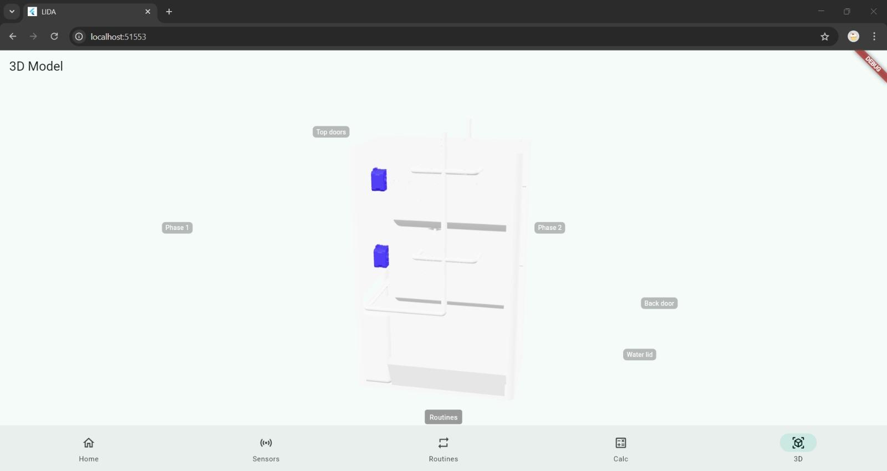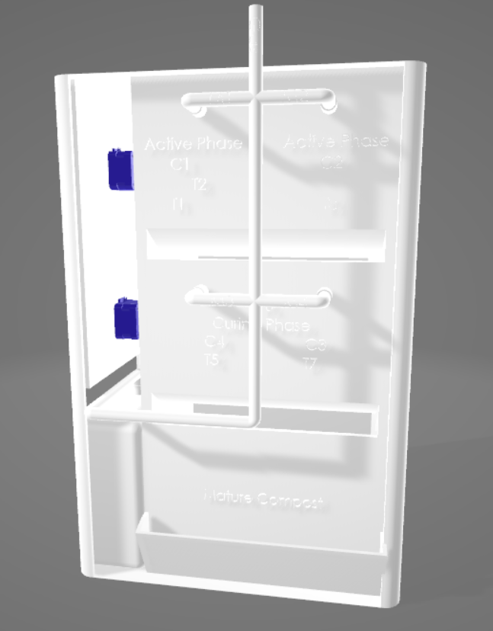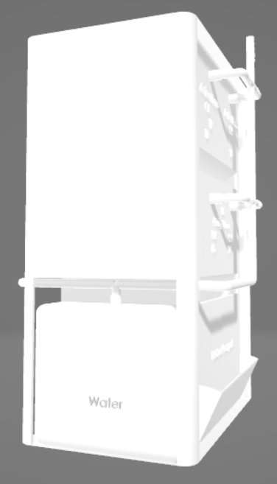
Figure 3.1: Loaded 3D GLB model in the mobile app.
- Replaced the previous sensor panel idea with a working calculator that gives the best Carbon-to-Nitrogen (C:N) ratio based on the waste materials inputs by the user to enhance the app’s usefulness for working on compost.
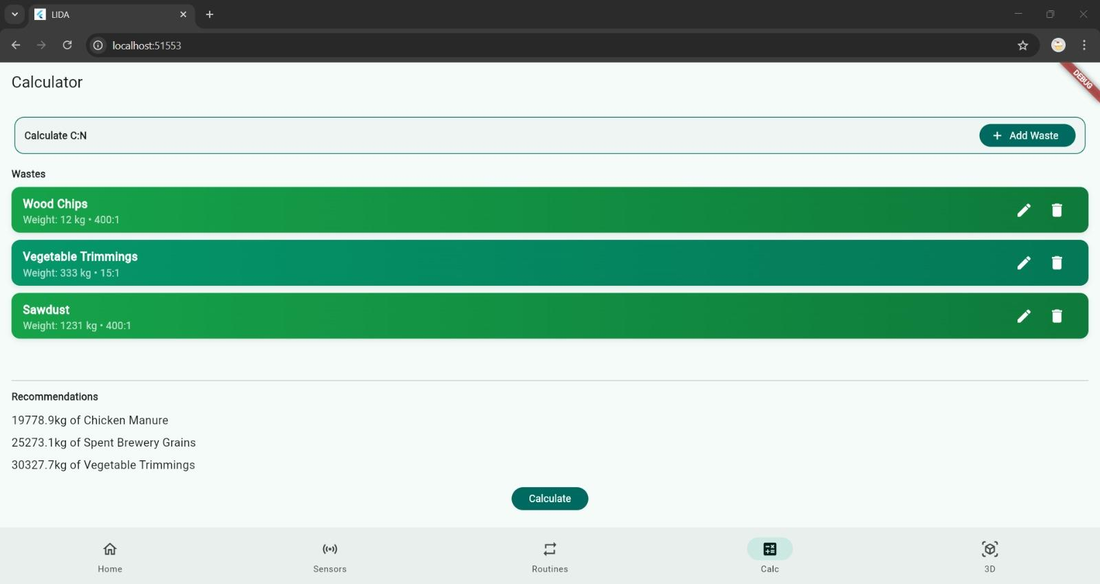
Figure 3.2: Compost Ratio Calculator in the LIDA App, showing inputs from the user and composting recommendations generated.
- The ability to link the readings taken by the sensor back to physical locations in the 3D model through the interactive highlighting capability.
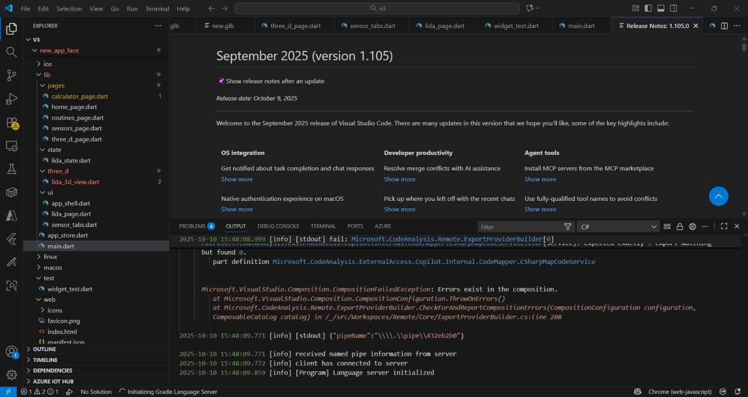
Figure 3.3: Visual mapping of temperature, gas, and moisture pathogen sensors.
- Animation examples to show the movement of components and the composting process to provide an educational visualization.
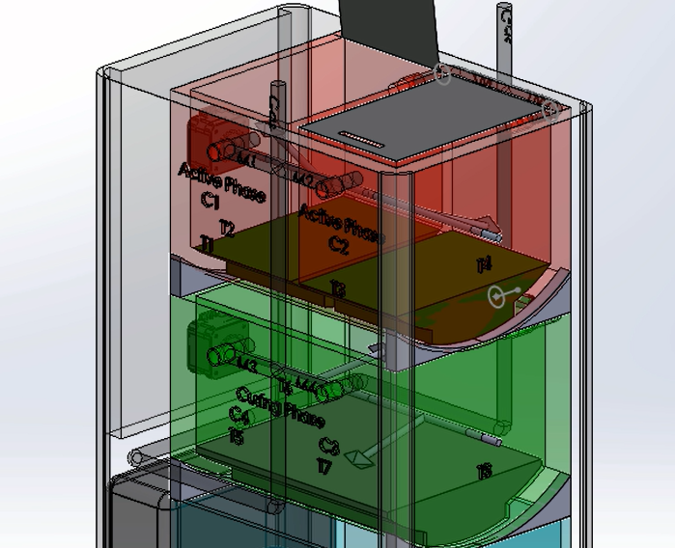
Figure 3.4: Animation and process flow in the compost model.
- Using an early concept of monitor display to show the feedback from the simulated live feedback inside the model.

Figure 3.5: Monitor-style interface showing simulated readings.
Client Feedback
Mr. Alex Jaimes Castillo communicated his satisfaction with where we are as in regard to the developments and its respective deliverables in regard to the Sprint 3 increment. He qualified that the core integration and structural designs of the panel are complete, and some materials still needed refinements before the delivery of the product.
- The GLB model renders nicely, but several of the volumetric components merged together into one mesh and textures lost colour.
- The client enjoyed the motor colour and wanted to keep it as a reference for fixing all material mapping.
- The new sensor panel was well received as the layout and visual flow was clear and easy to understand. The client noted that this will improve the interactivity and develop understanding.
- Alex wants the animations to have a more simplified format to make the animations realistic and easier to educate.
- The client suggested preparing a usability testing survey for new users to collect data on ease of navigation, clarity of interface, and response time.
- Alex is suggesting that we try and include some external testers to get a general understanding of usability and testing prior to delivering the full product.

Assessment of Progress and Reflection
Sprint 3 represents an outstanding moment from building the model further into the app environment. The integration of the 3D model into GLB confirmed the multi-platform capabilities. The new sensor panel's position and layout built functional value in the mobile interface.
We had some issues with visual variables sandwiched together during the conversion of the GLB interface and time restrictions that limited the refinements for the UI. The team was quick to respond at a relevant timeframe and to test the variable by isolating the motor component, which kept its texture in isolation to fix the mapping issue. The adding of the monitor concept into the model was an innovation that will allow the live feedback component to better witness the demonstrations within the variation.
Haritha and Chrishelle pushed forward on the testing and usability preliminary planning while Haritha created the internal schedule for testing and Chrishelle prepared the initial survey for usability. The entire team had very little down time to build upon the workflow and made relevant and timely communication to the client throughout the process providing we were collaborating for clear next steps to prepare for Sprint 4.
Overall, the third Sprint marked considerable technical advancement towards deliverables on the next Sprint to finally complete three weeks of work.
Challenges and Resolutions
Challenge | Description | Resolution
Colour and Material Merging | Some 3D model components appeared as one mesh in the GLB export, losing individual colours. | Compare material settings with motor components and re-export models with separated meshes.
Animation Complexity | Early animation sequences were overly detailed, reducing clarity. | Simplified movements and kept visualisations educational and realistic.
Sensor Panel Mapping | Minor delay in linking sensor data to correct model positions. | Adjusted coordinate mapping for each sensor to ensure accurate highlighting.
Usability Testing Preparation | Testing plan not yet formalised. | Began developing a usability survey and identified a small group of external testers.
App Responsiveness | Slight lag during GLB model rendering on mobile devices. | Reduced polygon count and optimised model export to improve performance.

Retrospect (Critical review of the process)
Overview
The retrospective for Sprint 3 was held remotely on Friday, 10 October 2025, from 14:00 - 15:30. The session had the full complement of team members present. The meeting was an opportunity for the team to reflect on the progress made during the sprint, where the pain points were, and whether the team flow was implemented as planned. Overall, strong points from the sprint included the successful integration of the SolidWorks 3D model into the LIDA mobile app, completion of the design of the sensor panel and testing of the GLB export was able to take place. The team reviewed as a whole the performance, communication and client feedback to highlight key strengths and opportunities for improvement.
Team Process Overview
During the entire Sprint 3 process, the team was able to coordinate well as a group, and follow the Agile process as discussed and planned. The team were able to meet once a week, to review their use of Jira and ensure they were working in aligned chronological tasks towards the sprint goals.
Strengths:
- Strong collaboration between the mobile team and the 3D modelling team.
- Good timeliness on team updates on information from the client that were then disseminated through information via social media etc.
- Good problem-solving identified in addressing model colour and mesh challenges.
Challenges highlighted:
- The exported GLB model merged all parts into one mesh, which lost material differentiation.
- Some UI responsive issues were observable on the mobile app during sensor panel testing.
- The testing devices we had available did not support as many devices as intended, this slowed some initial performance validation testing.
Responses to Challenges:
- The merging material problem was diagnosed by accessing mesh data from the motor component, in which all textures were retained.
- The response time of the app was remediated with reduced polygon and optimised animations; helped reduce response time.
- All testing was distributed across multiple devices after the devices were configured and to facilitate the best testing, end needed to stagger the testing to keep the items all equal performance wise. Could confirm testing was reliable.
In the end the team process for this sprint was effective in their managing of the entire team process. Members showed great contributions and corrective actions to bringing solutions to technical issues agreeable in moving into usability testing in the next sprint.
Code of Conduct from the Team
The team was still able to uphold the mandatory code of conduct emphasis on respect, accountability and open communication.
- All members attended all scheduled meetings, and completed their assigned Jira for the event.
- All feedback was done in a professional manner, and each decision was made collaboratively.
- All task progress in Google Drive was openly communicated through these weekly reports.
With no conflicts, or major communication challenges revealed the team took the time to develop, and required discipline continued to build a rhythm to the work flow over the sprint.
Meeting Details
Date | Time and Venue | Attendees
10th October 2025 (Friday) | 2:00 PM – 3:30 PM, Online (MS Teams) | Chrishelle Anthoneyz, Haritha Perera, Thenura Kuruppuarachchi, Senupama Deshapriya
Retrospective
Start Doing | Stop Doing | Keep Doing
Conduct usability testing sooner to provide time for handling analysis. | Overcomplicating animations past the educational purpose of the project. | Professional and frequent communication with the client.
Optimize model textures and resolve material mapping before exporting GLB models. | Waiting till the end of a sprint to validate how models relate and render with the app. | Working in teams, having documentation processes, and maintaining the Agile process.
Be sure to develop usability survey templates prior to the test phase. | Using a single device to complete performance testing. | Managing teams’ activities on Jira and in weekly reviews.
Action Items for Next Sprint
- GLB Material and Colour Mapping Fix
Assign the material groups in SolidWorks, and ensure that the layers of the mesh are separated friendly so that the colours will be realized within the exported GLB files.
- Finish Sensor Panel Integration
Finish mapping all three sensors (temperature, gas, moisture) to the real-time display.
- UI Responsiveness
Change layout scaling, spacing and refresh rate for a more fluid sensor panel on mobile devices.
- Prepare and Conduct Usability Testing
Finalize the survey forms focused on clarity, navigation, and user satisfaction, and start to gather feedback from users that are not close to us.
- Integrate Monitor Display Module
Put the interactive monitor into the 3D model to simulate live data from the system itself.
- Simplify and Polish Animations
Optimise visual transitions for educational purposes to clarify what performance capabilities we have built out, and be efficient.
- Plan Client Mid-Sprint Check-in
Arrange for a quick meeting with the client to share updates prior to the final sprint demonstration.
Cybersecurity and Ethical Protocols Review
In preparation for testing and usability evaluations to occur throughout the next sprint, the team formed a review of relevant cybersecurity and ethical protocols to assess if we’re operating in accordance with ethical practices and have security of the data we will gather.
- Australian Privacy Principles (APPs) - All collected or simulated data from the sensor will happen in accordance with the APPs. The team will not collect or store any personally identifiable information (PII).
- Data Security - All data gathered from testing and usability evaluations will be stored locally in encrypted project folders, and only shared with members of the team authorized to view.
- Ethical Data Collection - Any participants gathered from usability testing will be clearly informed of the evaluation, and all collected will not be connected to their identity.
- Transparency - Users and testers will be clear when simulated data is being displayed, where simulated data will be made apparent in case the tested no live readings from the system.
- Responsible Development - The team will specify in the technical handover guide and user manual how data will be handled to ensure responsible use of system data.

Lessons learned (Critical review of SPRINT one experience and future plan)

- Evaluating GLB Exports Requires Longer Lead Time
The primary takeaway from Sprint 3 is that the team should have tested GLB model exports at the beginning of the process, rather than at the end of the sprint. The team came to terms with the fact that by waiting until the end of the sprint to test the exported file, it didn't allow enough time for a potentially time-consuming correction when the colour and material information merged. Efforts should be made in the future sprint to perform early exports, once a week at the minimum, to start troubleshooting these issues.
- Interactivity Increases Engagement but Increases Complexity
By incorporating the sensor panel and the real-time highlighting of the model, we simultaneously enhanced the user experience, but further complicated the integration and mapping of data. The team learned to keep in mind the mission of balancing complexity and functionality by only incorporating specific and relevant features that ultimately develop the educational value, not necessarily interactivity.
- Reduced Animations Improve Performance
The application produced visually exciting animations; however, they created longer render times within the app and reduced responsiveness. While extricating some of the visually compelling aspects, and maintaining a medium frame-rate, simpler movements both produced a clean visual finish and improved application performance. The main takeaway was that smooth, simple, and effective animations are more important communicatively than more complex and exciting animations.
- Frequent Communication Occurs in Order to Avoid Design Misalignment
Frequent check-ins and updates provided to the client as a team, during Sprint 3, were necessary in order to avoid miscommunication about the integration of the models and the UI layout without having to undue or redo work. Through consistent communication with the client in Teams and via WhatsApp were necessary to maintain the rhythm of the project and mitigate design misalignment. It is essential to continue to and keep this rhythm in the following sprint but at least once before the break.
- Plan Usability Early in the Planning Process
The team also concluded that waiting until the final week of the project to compose and design materials for usability testing is a premature step that can delay usability testing by adding time to the project. In which, if we had prepared the usability survey that is general in advance and the extent of the usability session evaluated prior to testing, we could have immediately started usability once integration was completed, ultimately producing a better usability testing experience and evaluation materials. This lesson has already concluded, and we will be revising usability tests favorably during our next sprint.
- Model Optimization Affects Overall Performance
Sprint 3 demonstrated that 3D geometry, even changes that are small (like polygons or transparency layers), provided for a sense of extrinsic value for usability and a type of responsiveness when compared to a full export build. The team learned that we needed to optimize the model files incrementally through the exporting of lighter models for testing rather than waiting for a full build to test all models.
Practical and Feasible Future Suggestions
Area | Recommendation | How it will be implemented
GLB Export & Visuals | Conduct GLB exports every week in order to identify and resolve any problems with merging material prior to problems surfacing. | Assign one person from the team (Thenura) to ensure the exports and validate quality.
Animation Logic | Make sure all of your animations are succinct, focused and on point with regard to composting operations. | Consider reviewing your animation timelines for anything in your sprint review.
Sensor Integration | Incrementally link your sensors versus linking everything in one shot. | When beginning to test the sensor module, do so and one module at a time v. all three modules together.
Usability Testing | Confirm that your test forms and metrics have been in development for a sufficient length of time prior to the end of the sprint. | Chrishelle and Senupama are to finalize surveys and get them out to participants before testing begins at Sprint 4.
Model Optimisation | Begin developing light versions of the model for testing in the applications. | Haritha & Thenura are going to export and test light files weekly before the testing phase.
Communication | Continue to hold weekly client check ins and then also with the hardware group. | Plan to have more internal meetings in the middle of sprint 4 in order to help confirm deliverables.

Plans for Next Sprint (Sprint 4)
- Wrap up Monitor Design and Integration.
- Finish Full System Testing with the hardware team.
- Verify App & Model Validity.
- Polish Visuals and Materials.
- Complete Documentation & Handover Documentation.
- Prepare Final Capstone Presentation and Presentation for the Expo.

